**FUNDAMENTAL OF PROGRAMMING   
LAB TASK # 5**

**SUBMITTED BY ABDUL MANAN  
QALAM ID : 462449**

TASK 1

#include <iostream>

using namespace std;

int main() {

int x=1;

do{

cout<<"enter a number "<<endl;

cin>>x;

}

while(x>0);

return 0;

}

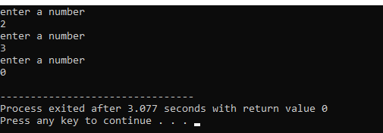

TASK 2

#include <iostream>

#include <math.h>

using namespace std;

int main() {

int num1,num2,i;

double ans;

char op;

do{

cout<<"PLEASE ENTER THE NUMBERS"<<endl;

cin>>num1>>num2;

cout<<"PLEASE SELECT THE OPERATION FROM THE FOLLOWING +,-,/,\*,%,^"<<endl;

cin>>op;

switch(op){

case '+':

ans=num1+num2;

break;

case '-':

ans=num1-num2;

break;

case '\*':

ans=num1\*num2;

break;

case '/':

ans=num1/num2;

break;

case '5':

ans=num1%num2;

break;

case '^':

ans=pow(num1,num2);

break;

}

cout<<"ANSWER = "<< ans<<endl;

cout<<"press 1 to continue or 0 for termination of operation"<<endl;

cin>>i;

}

while(i==1);

return 0;

}

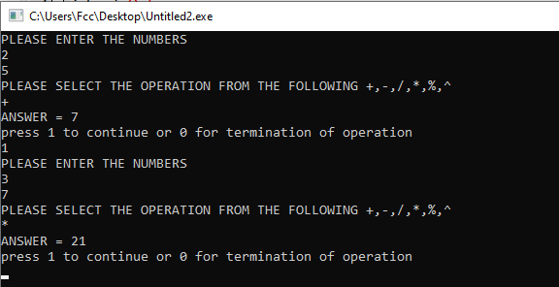

TASK 3 (A)

#include <iostream>

using namespace std;

int main() {

int sum,i=2;

do {

sum=sum+i;

i+=2;

}

while(i<=100);

cout<<sum<<endl;

return 0;

}

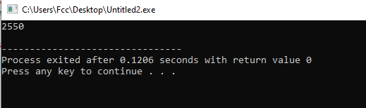

TASK 3 (B)

#include <iostream>

using namespace std;

int main() {

int sum=0,i=1,z;

do {

z=i\*i;

i+=1;

sum=sum+z;

}

while(i<=100);

cout<<sum<<endl;

return 0;

}

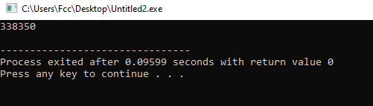

TASK 4 (A)

#include <iostream>

using namespace std;

#include <math.h>

int main() {

int a;

do{

cout<<"2 "<<"^ "<< a <<" = "<< pow(2,a)<<endl;

a++;

}

while(a<=20);

return 0;

}

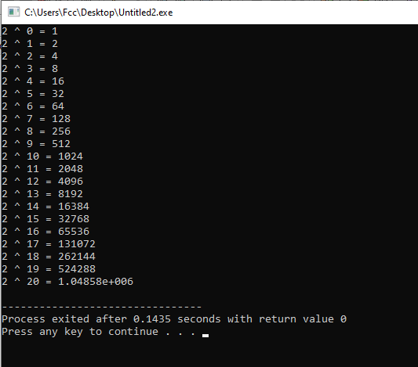

TASK 4(b)

#include <iostream>

using namespace std;

int main() {

int x,y,sum;

cout<<"INPUT THE INTERVAL"<<endl;

cin>>x>>y;

if (x%2==0) {

x+=1;

}

do{

sum=sum+x;

x+=2;

}

while(x<=y);

cout<<"SUM = "<< sum<<endl;

return 0;

}

